**ASSIGNMENT 11.2**

**Problem Statement:**

Write the Pig codes to analyze the Student data set.

* Find the number of students who scored less than 5(50%).
* List the name of students who are from Alaska.
* How many government colleges are there in Alabama?
* List the name of students who are from Oregon and pursuing BE.

**INPUT (DATA SET):**

The data set can be downloaded from the following link

<https://github.com/prateekATacadgild/mAPrEDuce/blob/master/studentDS>

**DATA SET DESCRIPTION:**

1. Name: chararray

2. Col.Undertaken: chararray

3. Dob: chararray

4. Stream: chararray

5. Grade: float

6. State: chararray

7. City: chararray

**PROGRAM:**

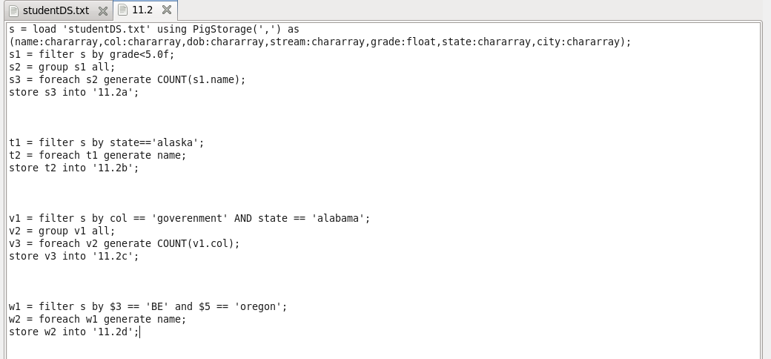

**OUTPUT:**

